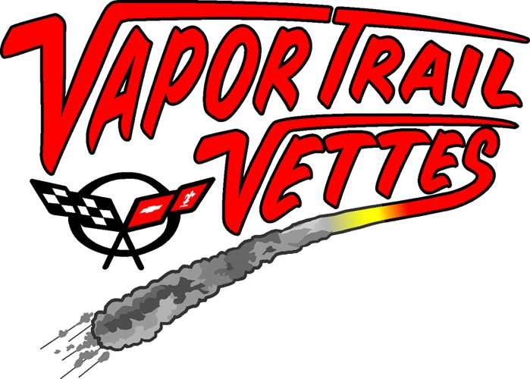
LOW SPEED AUTOCROSS ~ ALL CARS WELCOME!
Saturday, July 10, 2010
Hancock College ~ Lompoc Valley Center
Registration
NCCC Non-NCCC
$40.00 $50.00
* An additional $20.00 will be added to the cost of registration for persons registering on site. Cash only on date of event!

2 Sanctioned Events WC-518-045 & WC-518-046
Name | Address | Phone/E-mail | Drivers Lic. # | NCCC #
Driver 1 |  |  | Expiration Date:
Driver 2 |  |  | Expiration Date:

Year | Make/Model/Color | Stock Options | Engine Size/Hp Rating/Mods | Tires | Body Mods
Street ____
Race ____
** Use this Driver 2 registration only if Driver 2 will be autocrossing the same vehicle as Driver 1. If Driver 2 will be autocrossing a different vehicle, please complete a separate registration form.

Autocross classifications are as outlined in NCCC guidelines. Non-Corvettes will be classified together in one class. Proof of valid driver’s license and current insurance is required at time of check in. NCCC members must show their NCCC card to be eligible for points. Participants must be at least 18 years old. Approved helmets are required. Cars will be divided into a minimum of two run groups, depending upon the number of entries. Participants not running are asked to volunteer as a course worker.

Registration: ______# drivers @ $40 / $50 = $________
Total: $________
Send check payable to Vapor Trail Vettes to P.O. Box 5241, Santa Maria, CA 93456-5241. Questions? Call Gale Haugen at (805) 773-4515, e-mail galehaugen@charter.net or John Mahoney at (805) 937-1414, email jd.mahoney@verizon.net.

PLEASE NOTE: Participants who mail entries too close to the date of the event and is not received by Vapor Trail Vettes will be required to pay the on-site registration fee. Your mailed entry will be returned to you later.
Directions to Autocross: From South ~ North on 101 to Buellton/Solvang exit, turn left onto CA-246, right on Purisima Road (Purisima Rd becomes CA-1 (N/Cabrillo Hwy), continue through H Street stoplight then turn left onto Hancock Drive at second stop light. From North ~ South on 101 to Clark Ave exit, turn right onto Clark Ave, left onto CA-135 south, merge onto CA-1, continue on CA-1 towards Lompoc/Vandenberg Air Force Base. Turn left at VAFB main gate light, right onto Hancock Drive. Address is: 1 Hancock Drive, Lompoc.
Watch for VTV Event Signs!
Registration & Tech Inspections ~ 7:30 – 8:30 am
Drivers’ Meeting ~ 8:30
First car out at 8:45
You must be in the gate no later than 8:30 am.

