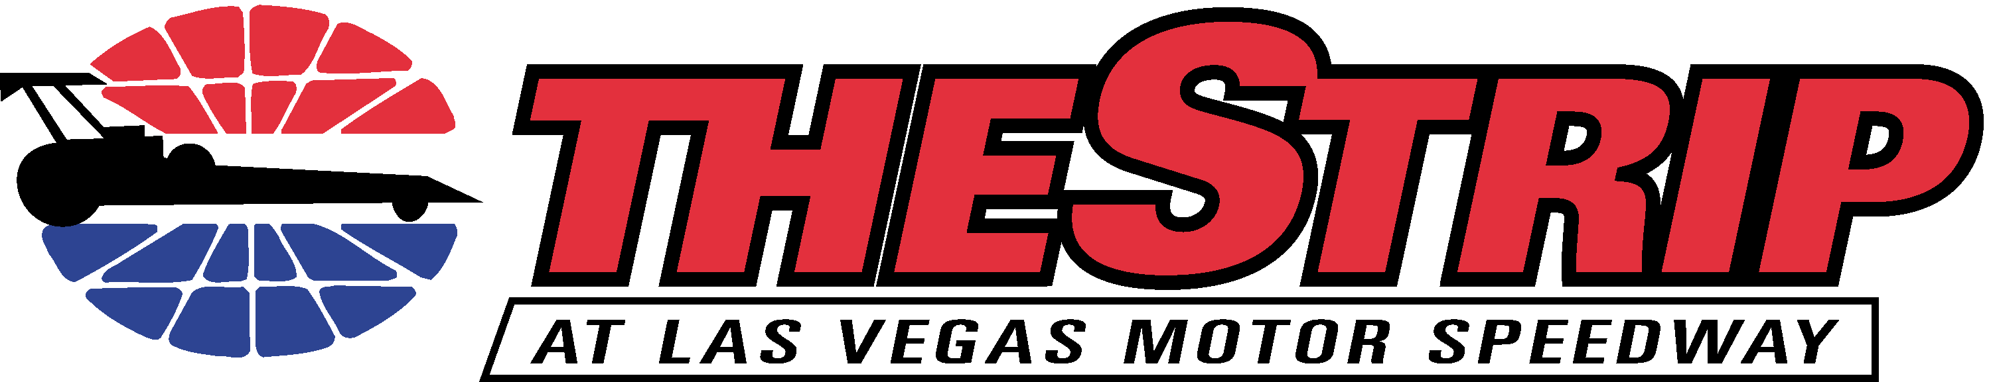
Wicked HP E.T. Bracket Series – Final Weekend
NHRA National Dragster Challenge
September 10-11-12, 2010

Friday, September 10
4 p.m.: Gates open
4 p.m.: Tech inspections begin
4:45 p.m.: Jr. Dragster Test Run #1 / Alcohol Test Run #1
5 p.m.: Open Test ‘n’ Tune for LVMS Bracket classes
5:45 p.m.: Jr. Dragster Test Run #2
6:45 p.m.: Jr. Dragster Test Run #3 / Alcohol Test Run #2
8 p.m.: Weekend credential sales conclude / No pit parking after hours
8:30 p.m.: Staging lanes close
8:55 p.m.: Alcohol Test Run #3
9 p.m.: Dodge Midnight Mayhem

Saturday, September 11 – Short Line Express/Chevron Jr. Drag Racing Series
7 a.m.: Credential Sales Open
8 a.m.: Tech Inspection
9 a.m.: Time Trial Run
Reaction Time Qualifying Run
Round 1 Eliminations

Saturday, September 11 – Wicked HP E.T. Bracket Series – State Championship Race

3 p.m.: Credential Sales for new arrivals
4:30 p.m.: Tech inspection for new arrivals
5 p.m.: Las Vegas Corvette Association Time Trial #1 and Time Trial #2
Wicked HP Time trial #1 – Pro, Super Pro, Sportsman, Motorcycle, HS
Las Vegas Corvette Association Time Trial #3
Run-for-the-Money – Electronic, Non-Electronic, Motorcycle
Las Vegas Corvette Association Final Time Trial
Time trial #2 – Pro, Super Pro, Sportsman, Motorcycle, High School
Wicked HP Eliminations begin
Duck Race begins following round 2 of eliminations for 1st and 2nd round losers

Sunday, September 12 – Wicked HP E.T. Bracket Series – National Dragster Challenge
8 a.m.: Credential sales open
8:30 a.m.: RFC chapel service in drag tower media room
8:30 a.m.: Tech Inspection for new arrivals
10 a.m.: Time trial #1- Pro, Super Pro, Sportsman, Motorcycle, High School
Run-for-the-Money – Electronic, Non-Electronic, Motorcycle
Time trial #2 – Pro, Super Pro, Sportsman, Motorcycle, High School
Eliminations
1/8 mile Duck Race follows Round 2 of eliminations for R1 and R2 losers

Friday Night Staging Lane Assignments
Lanes 1 & 2: Pro Bracket
Lanes 3 & 4: Super Pro
Lane 5: Motorcycle
Lane 6 & 7: Sportsman and High School
Lane 8 & 9: Jr. Dragster Lightning and Thunder
Lane 10: Jr. Dragster Novice

Saturday Short Line Express/Chevron Jr. Dragster Lane Assignments
Lanes 1 & 2: Jr. Novice
Lanes 3 & 4: Jr. Thunder
Lanes 5 & 6: Jr. Lightning

Saturday and Sunday Wicked HP Lane Assignments
Lanes 1 & 2: Pro Bracket
Lanes 3 & 4: Super Pro Bracket
Lanes 5 & 6: Sportsman
Lane 7: Motorcycle
Lane 8: High School
Lanes 9 & 10: Corvettes / Duck Race

