SCCA AUTOCROSS GUIDELINES

FOR

LVCA

TABLE OF CONTENTS
CHAPTER ONE
WHAT IS AN AUTOCROSS?
How It Works, What It Consists Of
CHAPTER TWO
DRIVER AND CAR SAFETY REQUIREMENTS
Driver Safety Needs, Car Safety Needs, Safety Procedures
CHAPTER THREE
DRIVER REGISTRATION AND PARTICIPATION REQUIREMENTS
Where To Go, What To Do, What is Needed
CHAPTER FOUR
WORKER DUTIES
What They Are, What To Do, How To Do It
CHAPTER FIVE
THE TECHNICAL END OF SOLO II OPERATIONS
What To Do, Where To Go, What Is Required Of The Driver, How To Read A Course
CHAPTER SIX
Prepare To Run, On Course, Exiting The Course

CHAPTER SEVEN
ALL THE STUFF NOT COVERED IN THE OTHER CHAPTERS
SCCA Membership, The Las Vegas Region Points System, Special Events
APPENDIX
Driver Registration Form & Time Card, Worker Assignment Sheet, Typical Course Map
CHAPTER ONE
WHAT IS AN AUTOCROSS?
How It Works, What It Consists Of
SCCA Solo II, often better known as Autocross, to put it in simple terms, is the successful navigation of a course on a paved surface, usually a parking lot, outlined by cones, or pylons. The objective is to not only navigate it but to do it in as quick a time as possible without hitting any pylons or going off course i.e. driving outside the course boundaries. (LVCA and NCCC also have Matching Time Trials (MTT) where the goal is to get two runs with as similar times as possible.)
To attend and participate at an Autocross as a driver you are required to meet certain rules which are necessary to comply with the requirements of both SCCA (Sports Cart Club of America) the sanctioning body for our events, and the insurance company which provides the liability coverage for the event. Additionally you need to follow the procedures as outlined for the efficient progress of the event.
First and foremost there are driver and car safety rules. There are not that many and they are, for the most part, mostly applications of common sense. You will need to know the procedures and you will find that it will become an easy part of your Autocrossing regime.
Next you will need to complete the administrative process. Register for the event, take your vehicle through technical inspection, and attend the mandatory driver's meeting. You must be of legal age (or over 16 and under legal age with signed parental consent form), have a valid drivers license, a safe vehicle, and the entry fee (usually $40.00 - $55.00) to compete at an Autocross.
A primary requirement to participate at an Autocross is to 'work' as well as to drive. This is how an Autocross is able to be put on without a huge entry fee. There are no employee operational costs. No, there are no chain gangs here. Basically when you are not running on the course you will work as a 'course worker' or at another function required to put on an Autocross. This requirement is a MUST. If you do not work you cannot compete. The course workers also end up with the best show of all. They are right out there on the course, VERY close to the action!
You will need to know where to go and what is the actual operating process to participate in an Autocross. Using the vernacular of the news business, what, where, why, and when. What you need to do, where you need to do it, why you need to do it, and when you need to do it!
Then you need to know how to Autocross. This includes how to prepare for your runs, how to do the run, what to do after your run, where to go from there, what to do in emergency situations, what the course flags mean and how to obey them.
You may seriously consider becoming a member of SCCA and the local Region. Besides the social aspects, you qualify for the year end points trophies, you save on your entry fee (which will often more than pay your membership fee over the year), receive the Regional newsletter and the national Sports Car magazine from SCCA, plus many other benefits.
In the APPENDIX are a sample Driver Registration Card, a sample Worker Assignment Sheet, and a sample course layout diagram. The following Chapters will detail all the points covered above and more. You will have a good plain English and hopefully simple guide to help you become a successful Autocrosser from the start.
CHAPTER TWO
DRIVER AND CAR SAFETY REQUIREMENTS
Driver Safety Needs, Car Safety Needs, Safety Procedures
To participate at an Autocross you and your car must meet several safety requirements. You must wear a safety helmet meeting the latest or two immediately preceding Snell Foundation standards, SA or M 2010, 2005 or 2000. DOT approved helmets are not acceptable. If you do not have a helmet, you may rent a 'loaner' from the Region, which is usually $10 and they will hold your driver’s license until you return it. See the helmet keeper over by the Timing and Scoring trailer. If you use a loaner, please return it to the keeper when you are through and they will return your license. (LVCA has some loaner helmets that our members can use at no cost.)
Your car must have at least a factory seat belt in good working order, a battery that is securely held down, good tires with no smooth spots or other defects, no loose wheel bearings, good steering - not loose and sloppy, no fluid leaks, to name the primary items the 'Tech Inspector' will look for.
If there is a technical problem of any kind you will be allowed to fix it, if possible, then get re-inspected. If the problem is not of a serious nature from a safety standpoint for you or the other participants or workers, you may be allowed to run, but you will be required to have it repaired by the next Autocross.
When you are anywhere on the event property, except when running in competition on the actual course, you are to drive in a safe manner and not over 5 mph. When you are competing on course you are also expected to drive in as safe a manner as possible. Driving wildy will not only provide you with likely your worse times, but also possibly endanger the workers, and spectators, and even yourself. Please Drive Responsibly; you will still have one of the best thrills of your life!
As a worker, when on course you are the eyes for the Timing & Scoring people and by knowing the safety requirements you are a valuable asset who provides reports of any violations. SCCA and your Region is very adamant about this. Without proper adherence to the safety requirements we would not be able to provide these events very long for you to enjoy. Anyone who consistently performs in an extremely unsafe manner will be removed from competition and possibly banned from future events.
CHAPTER THREE

DRIVER REGISTRATION AND PARTICIPATION REQUIREMENTS
Where To Go, What To Do, What Is Needed
Before you come out, check your car out at home. Check for any fluid leaks, oil level, and tire air pressure. Air pressure should be at least at the factory recommendation and typically more. This is to keep the tire sidewall stiffer and keep the tread on the ground and not onto the sidewall. (On Marvin’s stock ’92, he runs 36 psi in the front and 34 psi in the rear.) Make sure the battery hold down is tight. This is one of the biggest faults that Tech finds. Remove any loose items not necessary for the event. It’s also best to have your car clean so your car numbers and class designations will stick to the car.
Be sure to bring lots of water so you can stay hydrated. Also, it probably is simplest to bring lunch. Bring a chair, sunscreen, some type of shade if you would like, and a tire pressure gauge. If you need more air, SCCA has a compressor at the event.
For SCCA the following are the typical classifications for Corvettes:
STOCK CATEGORY-only minor mods allowable but does allow DOT approved sticky tires
Super Stock (SS)
Corvette – C6 chassis, non ZR-1 2005-2012
Corvette Z06 – C5 chassis, 2001-2004
A Stock (AS)
Corvette – C5 chassis, non-Z06 1997-2004
B Stock (BS)
Corvette – C4 chassis, all 1984-1996
C Stock (CS)
Corvette – all 1963-1982
F Stock (FS)
Corvette – 1953-1962
STREET PREPARED CATEGORY-External bolt-on engine mods and suspension mods
Super Street Prepared (SSP)
Corvette – C6 chassis, incl. stock ZR-1 2005-2012
Corvette – C5 chassis, 1997-2004
Street Prepared Class B (BSP)
Corvette – all 1953-1996
STREET MODIFIED CATEGORY-Catch all for street registered cars on DOT approved tires but with many modifications
Super Street Modified Class (SSM)
Corvette – all
PREPARED AND MODIFIED CATEGORIES (BP OR EM) – Purpose built race cars on race slicks

Go to www.scca.com for the national website, go to downloads, and then down to the 2012 SCCA Solo Rules for the full details on category and classification determination.
When you arrive at the event site, park your vehicle and remove all loose items except your helmet, if you have one, from your car. Then proceed to the registration table, usually marked with a 'REGISTRATION' sign. There are typically two lines. One is for preregistered entrants and the other is for non-preregistered entrants. You can pre-register online at the SCCA local website, www.lvrscca.org up until Friday midnight on the weekend of the event. The first thing to do is to sign the insurance release form in either line and you will be given a wristband. If you are preregistered you will be given your entry form with a preprinted label with all required data included. Just proceed on to the payment station. With site fees going up all the time, SCCA member fees are now $40 and nonmembers are $55, typically, for all regular events. If you did not pre-resister, you will be given an entry form to completely fill out. If this is your first time at a Region's Autocross event for the calendar year, you MUST fill out the form COMPLETELY! Please PRINT CLEARLY so it is easily readable by the registrars. Be sure you include your SCCA member number if you are a member. If you do not have your membership card, and we do not know you, you will pay the non-member entry fee. If the registrar cannot clearly read it, you will be asked to correct it or even fill out a new Registration Form. This form is also used for the computer input and this is the last step in registration after you have made payment. After the data has been input into the computer, take your registration card with you to Tech.
Another major item is car numbers. There can be delays at events due to cars having duplicate numbers, illegible numbers, or the incorrect number especially if there are two drivers for the same car. This can often confuse the timing personnel and thus results in a hold up of the event. Those hold ups cost YOU runs, due to the time it often takes to resolve the issue. The number you request will be checked against the permanent number list for LVR SCCA members. Duplicate numbers will not be assigned. LVR SCCA members may choose any number between “0” and “2000”, excluding “600 thru 699”, if not already assigned as a permanent number. Car Numbers 600 thru 699 are RESERVED for weekend members and will be assigned for a single event only. Numbers and class designation are provided to weekend members on paper and are to be taped onto the side of the vehicle (using painter’s tape, which comes off easily when you are done).
If there are two SCCA members using the same non-permanent assigned number, the first one at the event will have initial priority, or the drivers with the same numbers can work it out between them and let us know. Once an SCCA driver is officially assigned a number, that will be the driver's PERMANENT NUMBER for the current year and the driver has priority on that number for the next year. If you do not compete the following year then your number will be made available for re-assignment to another driver.
Once you have completed Registration, install your car numbers and class designations on the side of your car. Your car needs to be clean for them to stick whether they are magnetic for steel bodies, static cling for fiberglass, or taped. They should be at least 8" in height and one inch thick and 4” high for the class designation. There are rolls of painters tape on a roll dispenser at the timing trailer you can use. Don’t take the dispenser though. Check again to make sure all loose items are removed from inside the car. This includes the driver’s side floor mat.
You will then proceed with your vehicle and drive safely to the area marked with a 'TECH' sign for Technical Inspection. You will place your vehicle in line, and if there are other cars ahead of you, stay in your vehicle if possible so you can keep pulling ahead as the line moves until you reach the Tech Inspector. You will then hand your Registration Form to him/her and open your hood and deck lid (trunk) so those areas may be inspected. Also be sure to have your helmet sitting in view in or on your car, unless you will be using a 'loaner' in which case inform the Tech Inspector of that fact.
Upon satisfactory completion of Technical Inspection you must immediately move your car back to your parking space where it should remain until you are instructed to go to the 'Pre-Grid' area, or if you are going off the event site for any reason. If you are instructed by the Tech Inspector to make any repairs before competing, he will advise you of whether or not you need to come back to Tech Inspection again.
At this point you are free to help with course setup, work on your car, socialize, or 'Walk the Course' (as will be covered later in this Guideline). In addition to helping with course setup, it is strongly recommended you walk the course before any event, as it will prevent much confusion for you later. The more times you can walk it the better.
From that point you are only REQUIRED to attend the 'Driver's Meeting', which is usually announced over the P.A. system several times before the meeting. Attendance at this meeting is an absolute MUST. If you do not attend you will NOT be permitted to compete. There are NO EXCEPTIONS to this. The most common reason a driver has for being confused about the day's operating procedure is “I didn't know.” Had the driver attended the meeting, he would have known. It is primarily a SAFETY requirement for attendance at the Driver's Meeting.
A note here; if you have arrived a little early you might consider helping with site & course setup. Help is mostly needed in 'chalking' course pylons, i.e. drawing boxes around all course pylons, unloading the Timing & Scoring trailer, and miscellaneous little things that need to be done to get ready for competition. Autocross events are a team effort and everyone is encouraged to pitch in so the event can get started as soon as possible. The same applies to post-event cleanup. Everything needs to be picked up and put back in the trailer and the site needs to he policed of all litter. Speaking of litter, we try to see that there are litter barrels available for our use, PLEASE use them! Your help is greatly appreciated and the site owners will be happy to have us back again.
CHAPTER FOUR
WORKER DUTIES
What They Are, What To Do, How To Do It
When you participant at an Autocross you are required to Work for one session in the morning and one session in the afternoon when your Run Group is not running. There are usually between 2 - 4 Run Groups at an event, depending upon the total number of entries. At the Driver's Meeting you will be informed of the Car Classes in each Run Group and the Run Group running order for the day. Before the start of each Run Session an announcement is made for all Workers for the Run Group that will be working to come to the Timing & Scoring trailer for assignment and to pick up any equipment required for their duties.
After the Driver's Meeting the first workers will remain at the trailer for assignment. and if there is a large course they may be put on or in a truck/van to be driven to the Work Stations. At the first worker call for each Run Group any changes of assignments will be made, whether by request or otherwise.. Covering the various worker assignments is as follows:
REGISTRATION These positions are usually already taken care of before the event.
TECH INSPECTION The TECH INSPECTOR is usually an experienced Autocrosser approved by the Safety Steward or Event Chairman or other Region Official to do technical inspections. The duty is to see that the driver and their car fully meet the safety requirements.
WRISTBANDS / WAIVERS Wristbands are issued to all who attend the event or simply enter the event site. Everyone is required to sign the insurance waiver whether they are competing or not. The WAIVER Worker is responsible to see that this is done and to make sure all persons entering the site sign a waiver and get a wristband.
SAFETY STEWARD The SAFETY STEWARD is a licensed official of SCCA whose presence is
REQUIRED at all SCCA sanctioned events. He is usually assigned by the EVENT CHAIRMAN or the SOLO Il CHAIRMAN. The event cannot be run without the SAFETY STEWARD's presence. If he is also a participant, then another Safety Steward will perform the duties while one runs, thus they are usually in two different Run Groups.
EVENT CHAIRMAN This is usually the person who has organized that day's event. It may or may not be an SCCA Region official, e.g. SOLO II CHAIRMAN. SOLO II ASST. CHAIRMAN, etc. It will usually be an experienced Autocrosser of several years who has experience with course design and setup, Autocross operations, Timing & Scoring functions and procedures and has a good understanding and interpretation of the SCCA Rules and Regulations for Solo II and will likely have previously performed every type of worker assignment.
COMPUTER DATA ENTRY This position is to run the software program for inputting the driver and car data. This system is used for both Driver Registration and Timing and Scoring.
Timing & Scoring Positions:
ANNOUNCER This position is for reporting the run results over the P.A. system and making any announcements
required or requested. The ANNOUNCER is usually an experienced Autocrosser or event attendee who will usually
do an on-going dialog and banter for the entertainment of the spectators. The ANNOUNCER will also be a backup
to the PYLON CONTROL worker in making any announcements to the Station Workers such as 'RED FLAG'. `HOLD START', etc.
TIMER This position runs the Timing System Computer. These are the Clocks to which are attached sets of sensors that each car goes through to provide the START/STOP functions for the Timing System. Your duty in this position is to input car number and class on the computer for each car plus any penalties, either pylons knocked over or a DNF (Did Not Finish or Off Course).
PYLON CONTROL This worker's job is to keep track of any driver penalties, i.e. pylons knocked over, off course, did not finish penalties. Communicating via radio, a Worker Station will call in a penalty, which the PYLON CONTROL worker will reply an acknowledgment to the Worker Station such as “Station 6, one pylon for Car 45 blue”, or “Verify off course Car 14 Red/White” or a reply to that effect. It may be car number/class, color or model of car, or whatever gives positive confirmation of the driver affected. The BACKUP RECORDER then relays the information to the TIMER worker in a timely manner so as to have the penalty included in the computer. It is also the duty of this worker to notify the announcer and all work stations in event of a 'RED FLAG' situation.

BACKUP RECORDER This worker keeps a running handwritten copy of each entry that runs, car number, class, run time, and any penalties for every run as a backup to the computer system.
STARTER The duty of the STARTER is to release the driver's on their run. The worker will give a last minute check for helmets, seat belts, and hands/arms inside of the car. The STARTER will keep “tuned” into the Timing & Scoring trailer and to the ANNOUNCER in the event that the STARTER is requested to hold the start, i.e. stop releasing cars either via the P.A. system or a radio, if issued one, or both. The same goes for when to restart the runs. The STARTER will make sure that the cars are lined up at the proper line for release, let the driver know when it is close to release time, usually by raising a furled GREEN FLAG above the head, then release the car when it is time by dropping the GREEN FLAG. Then the next car is directed to the START line and the process is repeated. Another vital safety concern of the STARTER is if a Worker or spectator is spotted on or very close to the course driving lane he will NOT release a car and will report it immediately to Timing & Scoring. Often over-enthusiastic spectators will get as close to the driving lane as possible, or even on it for a 'better view'. THIS IS A DEFINITE NO-NO!
GRID CONTROL The workers assigned for this position will manage the PRE--GRID area. They will make sure that all drivers (and any passengers that are permitted) are properly seated in their car and helmet and seat belts properly fastened. They will make sure all drivers are in their car and ready in the row that is currently being released for runs. They will also caution the occupants of the car to keep their hands/arms inside the car at all times. One grid worker will be the 'Release' or 'Staging' worker who sends the cars to the START line and sees that there are enough cars lined up at the START line to provide continual flow to the event. The other grid worker(s) will perform the above duties in the PRE-GRID area. One or more of the PRE-GRID workers are issued radios to keep in contact with Timing & Scoring.
TIMING SLIPS This worker is stationed at a position AFTER the course EXIT and fills out a TIMING SLIP to give the driver after a run. The worker will get the information. Car number. Time. Penalties (if any) either from the ANNOUNCER's announcement or via radio. If unable to understand the announcement or one is not given for some reason the worker can call the Timing & Scoring to get the information. An additional responsibility is to keep the EXIT clear of cars and pedestrians.
COURSE WORKERS There are always several Worker Stations to be manned with usually two, or more, to a station. The stations are usually already set up with spare pylons, a station number, and a fire extinguisher. There is also a RED FLAG and a radio issued to each Work Station. Each Work Station is responsible for the course area in it's immediate vicinity, usually from a point approximately halfway from the previous station and halfway to the next station. It may differ from Region to Region or course to course, in which case an announcement will be made at the Driver's Meeting or at Worker call. If you are inexperienced, you will be placed with an experienced Station Worker your first few times. Be aware that you may be moved to a different station than the one you were originally assigned. The same really applies for the other worker assignments as well.
The procedure for the Work Station is as follows: when a car either hits a pylon or goes off course, a Worker will, after checking to see if it is safe, go on the racing lane, go to the pylon and replace it in it's original position and verify that it is indeed a penalty. Or if it was just nudged and is still standing in or touching the chalked pylon outline, then there is no penalty. Then a report is radioed to Timing & Scoring describing the penalty such as 'One pylon on Car 45 blue', or 'Off course Car 14 Red/White' or a report to that effect. It may be car number/class, color or model of car, whatever gives positive identification of the driver affected.
AT NO TIME DO YOU ENTER THE RACE LANE WHEN A CAR IS ANYWHERE IN THE VICINITY OF YOUR WORK STATION! It is extremely dangerous and there is no need to expose yourself to that danger! If you need more time on the race lane a call should be made to Timing & Scoring to 'HOLD THE START' for course cleanup. If there is an additional car already on course approaching your area where there is a stalled car, slow moving car, or course needing cleanup (meaning multiple cones need to be set back up, not just a single cone or two), the worker Station upstream from you and you should be waving the RED FLAG. Your safety is vital to us. Time is always available for safe operation. Also be sure at least one Worker is ALWAYS facing the direction of the on-coming cars. Occasionally a car may go off course in such a manner that it may approach your work station at speed or otherwise, in which event you are able to notify your fellow Worker in time to get a safe distance away. Don’t try to out run the approaching car, but instead move to the side, out of its path.
Once the 'Run Session' is over you will receive an announcement via radio and/or P.A. System to that effect. You will be informed as to whether you need to bring in any equipment with you when you come off the course. Go to and return from your Work Station as quickly and safely as possible so as to keep the down time between 'Run Sessions' as short as possible, which will often translate into more runs for everyone including you!
SPECTATOR SAFETY When needed for some events, such as events held in extremely public areas such as at Casinos, etc., Workers are often placed to keep any spectators that may approach the course from getting too close to the Race Lane. That is the primary and only responsibility for the SPECTATOR SAFETY Workers.
CHAPTER FIVE
THE TECHNICAL END OF SOLO ll OPERATIONS
What To Do, Where To Go, What Is Required Of The Driver, How To Read A Course
Now to the fun chapters, the part that covers why you are at the event in the first place. Autocrossers love to run, and they want to get as many runs as possible. This is best accomplished by everyone following all the rules, regulations, and procedures which allows a smooth continuity of runs and includes being ready to run while in Pre-Grid, making as `clean' a run as possible in the best time, leaving the course as quickly as possible in a safe manner, and returning to grid for the next run.
BE PREPARED! Those two words make a successful Autocrosser who has a lot of fun and gets good times. If you are prepared mentally and physically, and your car is mechanically ready, you will have a very good time and do very well at the event. You have complied with the REGISTRATION, SAFETY, and TECHNICAL INSPECTION requirements and are ready to go racing. Well, here's what's left to do.
First of all you will want to 'Walk the Course', both to see how it is laid out, and to determine your 'Drive Plan' or where the 'driving line' is. You will be looking for the best approach and exit for each corner and estimating the correct speed and gear. Be sure to pay particular attention to where the START and FINISH lines are. This is where the Timing Lights are on each side of the Race Lane. If you hit any of the yellow pylons before the START or after the FINISH lines, you will receive a DNF. You also need to understand what the different pylon arrangements are throughout the course.
The course is usually outlined with pylons and, generally, a chalk or flour line to mark the Race Lane (except for the Slaloms). There are also several other pylon arrangements that you need to be aware of. One is a GATE. This is where you will find one or more pylons standing up on each side of the course, sometimes with a ‘pointer’ pylon laying on it's side pointing to the Race Lane. This is usually seen at the start and end of a SLALOM but may be placed at other places such as the START and FINISH or EXIT lines. Essentially this type of a pylon arrangement is to let you know that you MUST pass between the standing pylons. Gates may also be a series of standing pylons without a ‘pointer’ pylon, and they often are used where the course is using a 'staggered gate' arrangement of several gates such as a maze.
The SLALOM is a series of pylons usually set up in a straight line (sometimes they may be staggered a little) between pointer type gates. There may be anywhere from only 2 to as many as 7, possibly more depending on the course area and the course designer. The objective is to go through the SLALOM passing the pylons on alternating sides and then pass through the gate on the opposite end back onto the Race Lane. How you approach the first pylon may be optional as to what side you start on. In some cases the course designer may place a 'pointer' pylon next to the first slalom pylon indicating that you MUST pass on the side opposite of the 'pointer' pylon. If you knock over or displace any of the slalom pylons you will be assessed a penalty.
Another often regular feature at an event is a "circle' which is entered and exited by either one or two gates. The circle is usually identified by three or more pylons arranged in a group to act as the center of the circle and often the outer radius of the circle is bordered by cones although sometimes not. You usually will find the direction you navigate the circle is optional, but sometimes a direction may be made mandatory either by 'pointer' pylons or the ENTRY gate will be placed in such a manner that a certain direction is the only way to go. An extension of the circle is the Figure Eight, which is, to put it simply, two connected circles, and which is set up to be run in a certain direction typically, but we have had some smaller course sites where we arranged the course to travel the Figure Eight twice, once in each direction. There are several other pylon arrangement's that I will not go into here, such as a 'Chicago Box' etc. Suffice to say, the above information will let you 'read' a course and know where the Race Lane runs. There are many variations that can be built into a course at the designer's discretion. His primary guidelines are DRIVER, WORKER, and SPECTATOR SAFETY, the same as yours.
As you mentally prepare for your runs keep in mind that you want to determine the best speed to run the course. Walking the course naturally is not the same as driving the course. At some events the participants are allowed an initial, parade lap at slow speed around the course. (NCCC events require a parade lap.) This may give you a little inkling as to the speed you want to run. Even having walked the course, what I do is to let my first run be a 'throw away' run: I do not try to make it my fastest time of the day. I use it to 1) make sure I know the course or at least am reading it correctly, 2) gauge just how fast I can run by not going at top speed to see where my brake and acceleration points will be, and 3) make sure of the feel and handling of my car and if any changes need to be made, e.g. chassis adjustments, tire pressure, driving style, etc.
Be sure to notice where the Work Stations are around the course, not only in case you will be a Course Worker, but also so that you will be aware of them during your run and will not be disturbed when someone is wildly waving a RED FLAG at you and shouting STOP.
CHAPTER SIX
Prepare To Run, On Course, Exiting The Course
Once the Driver's meeting is over you will be 1) going to your Work Station, or 2) taking your car to Pre-Grid to start your runs, or, in the event of three or more Run Groups, 3) just laying back to relax. If it is the last, go to watch the other drivers run. If it is time for your Run Group to run, get your car into Pre-Grid as soon as possible and follow the instructions of the Pre-Grid Workers. You may be asked to get in a certain line, or you may be allowed to get in any line for your first run. If you are in a two driver car, there is a special lane for that.
But once you are in that line, you should return to that line, and remain in the same order in that line, behind and/or ahead of the same cars. This will allow for a smooth efficient Run Session and thus the possibility of more runs. If you cause a hold-up of the START, or are out of line, or are not in your car and ready to run when required, you will simply slow the event progress down and reduce the number of runs for yourself, as well as for everyone else.
The Pre-Grid Worker will check to see that you are in your car, properly belted in and your helmet is properly fastened on your head. The same applies if you are allowed to carry a passenger. On C4’s the seat lap belt has a cinch button. On other years, pull out the belt so it locks on the lap belt or you can twist the buckle before inserting it, to keep the lap belt tight. Make the belt as tight as you can so you will be more securely held in the seat. This is just one less thing to distract you when you are on course. On your very first event, our region recommends that you have an INSTRUCTOR ride with you on your first run. The instructor need not be a licensed instructor, only a person who has plenty of Autocrossing experience. One will be acquired for you by the event staff. We always ask at the Driver's Meeting if anyone is a first time Autocross driver and we assign him an instructor. The instructor is not going to tell you how to drive, rather the instructor is to see that you understand the course layout, know where to go, are able to safely control your car, and may even offer to show you the correct driving line around the course. If you wish, you may request that the instructor go on additional runs with you. It's at his and your discretion and agreement. Also if you are a new driver and are having a problem on the course, you may be asked to have an instructor ride with you again to help you find the problem you are having. We want everyone to get clean runs and the best times they can, which you can’t do if you are lost or don’t understand something on the course. There will always be someone who can help you. Just let someone on the staff know when you return to grid if you would like some help or need to know where you went off course.
Well, it's time to run, you are in your car, you meet the safety rules and are now ready to go out on the course. The Pre-Grid Worker will let you know when to pull up to the START line-up. If you are located further back in the Pre-Grid, be sure to pull ahead as the car ahead of you moves up as those from your line will be pulling in behind you for their run. This is a good time to do a little mental preparation, take some deep breaths and relax, perhaps go over the course layout in your mind, or just relax and be mellow: this is no time to be uptight and tense. One idea to keep in mind is that this is just meant to be a fun thing to do. Don't get too serious, retain your sense of humor, and don't get upset if your run is not what you wanted it to be.
Okay, you are at the START line now, you are the next car to go out. One nice trick is to remove or turn up your rear view mirror, especially if you are a new driver, you do not want the distraction of seeing behind you and you do not NEED to see behind you - you can't fix that pylon once you have already hit it! This also gives you a better unobstructed view ahead of you to see the upcoming course. WATCH THE STARTER! If you have a passenger other than an instructor, ask him/her not to talk from now until you finish your run. The less encroachment into your concentration, the better. When the moment is nearing for you to start your run the STARTER will raise the GREEN FLAG. Be Ready to Go! Once the STARTER drops the flag you can go. It’s not a drag strip though and the timer doesn’t start until you cross the START line.
When making your run, be aware of the Work Stations in case of a RED FLAG. If you see a Worker wildly waving a RED FLAG, you must IMMEDIATELY STOP your car where you are at the time and wait to be instructed to move. You will be told where and how to go and will be given an immediate 'RE-RUN', in which case upon exiting the course you will bypass the Pre-Grid and be directed to the START line (if the Pre-Grid Worker asks, say you have a Re-Run).

Once you have crossed the FINISH or EXIT line where the Timing Lights are, IMMEDIATELY SAFELY SLOW DOWN! Proceed out the exit lane to the TIMING SLIPS Worker to get your Timing Slip. Then proceed SLOWLY (5 mph) back to your Pre-Grid line and if possible, get back in your same position to be ready for another run. If you just finished the last run of the Run Session, and your Run Group is to work the next Run Session, proceed immediately to the Timing & Scoring trailer to check in.
Just a couple more pointers here. Be Nice! To everyone and to YOURSELF. If you have had a bad run, don't worry about it. Face it, you will only have ONE best time for the day. If you are upset, that next run will also likely be a bad one as well. Just relax and think where the run went bad for you and what you will do about it. If you go out each run and try to drive as fast as you think the car will go, you may be going faster than YOU can go! As I said above, make your first a 'throw away' run. Then make each run progressively faster; brake later for the turns, accelerate sooner out of the turns, also concentrate on one section of the course at a time, don't try initially to be perfect on the entire course at one time! You can't do it! Not even the most expert Autocrosser can. That is why he/she is an expert. He/she knows how to gradually build to a best time of day! Take the hint.
Also think smooth. Make smooth steering inputs. If you are jerking the steering wheel you are upsetting the car. Same for the gas and brake. Modulate the throttle because with all your horsepower, flooring the gas could get you into trouble very quickly. Also for the brakes, squeeze them on. With ABS and traction control in today’s cars this is done automatically to some extent but sometimes it still might not save your run or it might slow you up.
Remember also that sometimes SLOW is FAST. It took me a while to learn that to my consternation over my poor times. Once in a while I still forget that fact and my run times show it! Making square tire-squealing turns around a corner sounds and looks impressive, but all you are doing is using up precious time while your tires spin and go nowhere fast. You want to work up to the point that when you take your turns you will be at a speed that will NOT spin your ties, but may make them squeal a little. That lets you know you are nearing the point of traction loss.
Where you can make up your time is on the straights (especially Corvettes!) and long sweeping turns, and even in the SLALOMS, if you do them right. I remember someone once told me that YOU cannot go faster, you can only go slower. Your car can though! Keep that in mind when you are out on the course. The rest is up to you - GO HAVE SOME FUN! And make sure it is fun with a good positive attitude and a sense of humor, and you will enjoy one of the more pleasurable days of your life. I personally totally look forward to each and every Autocross event and set aside many other things I could probably be doing that would provide nowhere near the pure pleasure that Autocrossing does.
Fm
CHAPTER SEVEN
ALL THE STUFF NOT COVERED IN THE OTHER CHAPTERS
SCCA Membership, The Las Vegas Region Points System, Special Events
Now for a few 'plugs' for the SCCA, our Region, etc. If you find you enjoy Autocrossing, which I am sure you will, JOIN THE SCCA and the local REGION! You will enjoy many benefits of membership; the national SPORTS CAR magazine from SCCA, the local REGION NEWSLETTER, lower Race Entry Fees, invitations to the periodic social events such as Socials, the annual FUN Christmas Party, and the yearly AWARDS BANQUET where you may receive a trophy for your year long efforts.
There are other race divisions in SCCA that you may want to get into such as Road Racing, Road Rally, or even RallyCross, which is essentially an Autocross in the dirt, usually held on a dry lake bed or other open non-paved location. It's a bit dirty, but LOTS of fun.
We at Las Vegas Region also have a special yearly competition with the Reno Region of SCCA called the NORTH-SOUTH CHALLENGE, an annual event for many years. It originally was held in Tonopah, but when the pavement became too bad there, it was moved to Hawthorne, NV, 300 miles north of Las Vegas at the Hawthorne Airport. It was always a long fast course. We are quite often outnumbered 3 to 1 by Reno as they only have less than 200 miles to drive, but a scoring system is used to defeat that and it depends primarily on how good the drivers on each team are, proportionately. It is a two day event held on Memorial Day weekend each year and is a fun sociable weekend including a banquet and with awards to the best drivers of each class plus the EVENT TROPHY to the Region that does best overall. The airport has not been available recently, but that may soon change.
A similar event is in the planning by the Salt Lake SCCA club with an event at the abandoned St. George, UT airport. They are saying it will be a long and fast course there also. This is planned for March 31st and April 1st of this year. Watch the forums on the SCCA websites for updates and details.
We also have had events in the past with the local Porsche Club, the Corvette Club, the Mustang Club and others. Usually they will be some type of charity event and you will usually still receive points for those events as well.
If you are an SCCA and REGION member, you will be able to participate in the points system. You receive points at each event based on your finishing and these points accumulate over the year. Then at the AWARDS BANQUET trophies are awarded for the top finishers in each Autocross Class. It is a prize not taken lightly by the avid Autocrosser and the goal we all strive to attain. You may do it your first year or it may take two or more, but rest assured, if you follow the above suggestions you stand an excellent chance of doing it!
Well, that's about it. I hope these guidelines have been of help to you and possibly provided a little insight and tips that will help make you a well organized, prepared, and successful Autocrosser who will have a lot of FUN!
William Prince
LVR 1999/2000 Asst. Solo II Chairman Las Vegas, Nv.
with updates, revisions and Corvette notes by Marvin Maize SCCA/LVCA 2012 and Cathy Wilson LVCA

APPENDIX

Driver Registration Form & Time Card
Worker Assignment Sheet
Typical Course Map
DISCLAIMER: The Sports Car Club of America and the Las Vegas Region and the Las Vegas Corvettes Association and the National Council of Corvette Clubs is in no manner responsible for contents of this publication, nor it's authoring or production of, and is not held liable thereof, and makes no warranty, implied or otherwise.

LAS VEGAS REGION SCCA

0
RUN GROUP
DATE
BY
AMOUNT -
Registration Information
CAR NUMBER CLASS
AUTOCROSS REGISTRATION FORM
IF THIS IS YOUR FIRST AUTOCROSS THIS YEAR FILL IN ALL OF THE INFORMATION BOXES. IF YOU HAVE ALREADY ATTENDED AN AUTOCROSS THIS YEAR FILL IN ONLY THE CLEAR BOXES.
NAME

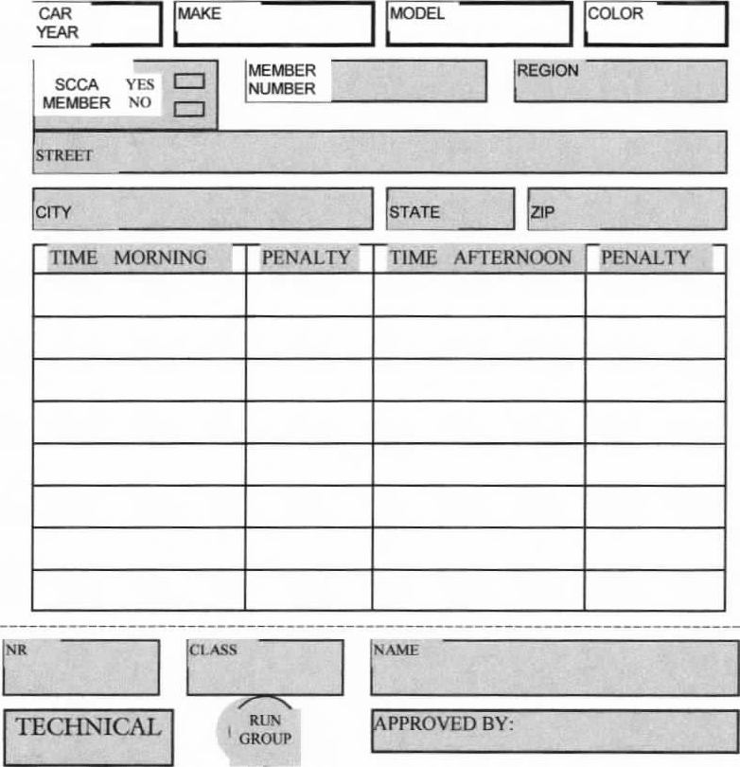
RUN
GROUP
TECHNICAL
[APPROVED BY:
SCCA \ I
MEMBER No
CITY
1 'STATE I
MODEL
STREET
MEMBER
NUMBER
MAKE
CAR YEAR
REGION
COLOR
'NANO
TIME MORNING PENALTY TIME AFTERNOON PENALTY
^{I}NR
_ASS
TIMING & SCORING TRAILER REGISTRATION

WORKER LIST
SPORTS CAR CLUB OF APAERICA
IF YOU HAVE THIS COLOR STICKER ON YOUR CAR
THIS GROUP: RUNS IST 2" 3RD WORKS 1ST DD 3RD
SIGN UP HERE
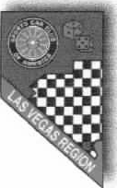
ANNOUNCER REGISTRATION
CLOCKS REGISTRATION
POSTING TECH INSPECTION
SORTING WRISTBANDS
PYLON CONTROL EVENT CHAIRMAN
PROM/1E COMPUTER OPERATOR
GRID
STARTER SAFETY STEWARD
GRID CONTROL
TIMING SLIPS
COURSE
STATION #1 A.
STATION #2 A.
STATION #3 A
STATION #4 A.
STATION #5 A.
STATION #6 A.
SPECTATOR SAFETY:
SPECTATOR SAFETY: NOTE: 31 entries needed for 2 run groups.
SPECTATOR SAFETY. 45 entries needed for 3 run groups.
'PECTATOR SAFETY.
OTHER #I OTHER #3
OTHER #2 OTHER #4
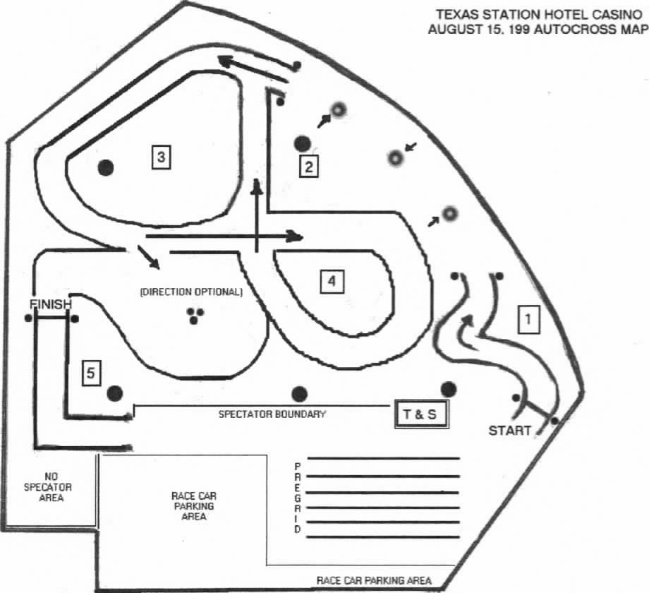
TEXAS STATION HOTEL CASINO
AUGUST 15. 1999 AUTOCROSS MAP

